

Programme | : | M.Tech Int Software Engineering | Semester | : | Fall 2026-2027
Course | : | Database Systems Lab | Code | : | IASWE206
Faculty | : | Dr. M. Premalatha | Slot | : | L31+L32

Ex. No. 3
Date: 20-07-2026
SQL Basics – Integrity Constraints

Note:
LMS Submission Format [Word File]
Regno, name
Course code, course title
Slot
Faculty Name
Question
SQL Query – Text Format (Copy Paste)
Screenshot

Ex:
Question:
create a student table with attributes regno, name, mobno and dob with appropriate datatypes and sizes

Query:
SQL> create table student_mp(regno varchar(4), sname char(10), mobno number(10), dob date);
Table created.

Screenshot:

SQL> desc student_mp
Name Null? Type
----------------------------------------- -------- ------------
REGNO VARCHAR2(4)
SNAME CHAR(10)
MOBNO NUMBER(10)
DOB DATE
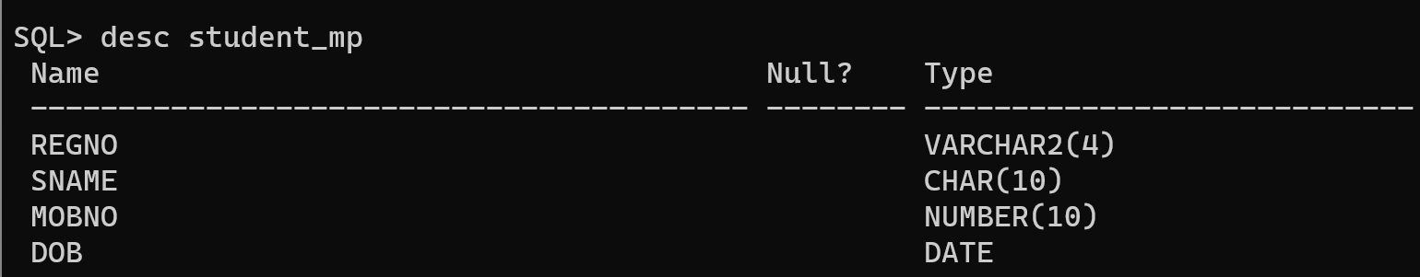

- Books Table:
  - isbn – primary key
  - title
  - price
  - qty – not null
- Authors Table:
  - Author_id – primary key
  - email - unique
- Book_Authors:
  - isbn – foreign key references books table
  - author_id – foreign key references authors table

- Create the above tables and apply constraints as specified during the creation of the table.
- For the already created books table, Add unique constraint to title
- For the already created books table Add not null constraint to price
- Alter not null constraint in price attribute in books table and set the check constraint so that value is greater than 0.0
- Drop not null constraint for qty in books table
- Set a default value of qty in books table as 0
- Drop unique constraint for email attribute in authors table
- Drop any one foreign key constraint.
- Drop a primary key [after referenced foreign key is dropped]
- Add an attribute for authors table and set a constraint for it.

